MCB6937 Syllabus Outline for spring 2023
Please do not use the Canvas Grade Book to determine your final grade in the course. Use the Syllabus or the Final Grade Calculator to see how you are doing.
Exam dates: All exams will be open for multiple days. This course is "information-dense," as they say, so you must spend some time each day keeping up. A survey of students in this course last semester indicated that the average time spent studying per week was from 4-6 hr.
1-Exams (92.0% of grade)

Spring 2023 Exam Calendar:
Exam 1 Jan 28-Feb 1 (7 hr of material) (17.3% of final grade)
Exam 2 Feb 25-Mar 1 (11 hr of material) (24.9% of final grade)
Exam 3 Apr 1-5 (13 hr of material) (24.9% of final grade)
Exam 4 Apr 29-May 2 (12 hr of material) (24.9% of final grade)
Optional re-take Final: May 3-5 (a chance to re-take your lowest exam. Only your highest score will be used.)
(Total from Exams + 92.0%)
2-Homework Quizzes (3.5% of grade)
3-Gene Structure/Bioinformatics Parts 1, 2, & 3 (4.0% of grade)
Due dates:
Part-1 & (Part 1B optional) Mar 9
Part-2 Mar 29
Part-3 Apr 6
4-Graduate Presentation: PowerPoint slides: Apr 27 (2.0%)
5-Genome Engineering 2022 all parts: Apr 27 (2.0%; optional extra credit)
6-COVID-19 extra credit Apr 27 (1% optional extra credit)

MCB6937 Spring 2023 Calendar of Events
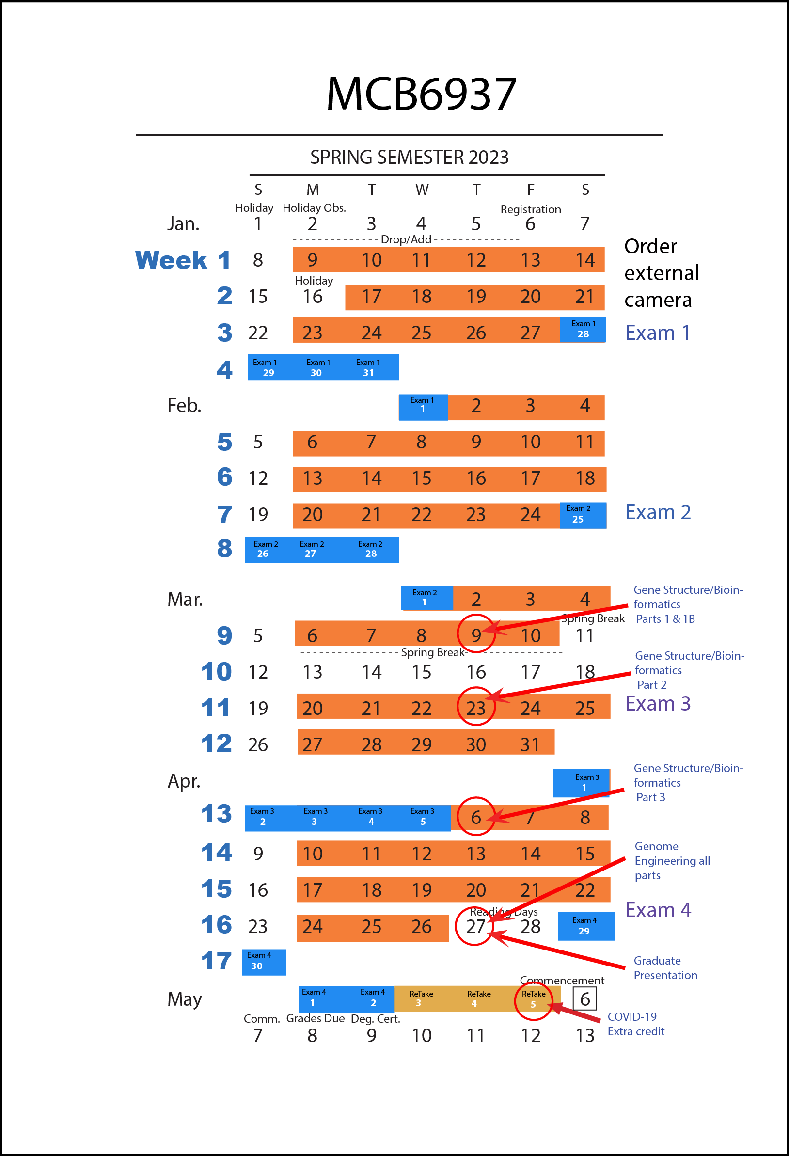

Grading Scale Numerical Equivalents
A = 91 or above | C = 68-73.99(minimum needed for major)
A- = 89-90.99 | C- = 65-67.99
B+ = 85-88.99 | D+ = 62-64.99
B = 81-84.99 | D = 58-61.99
B- = 79-80.99 | D- = 54-57.99
C+ = 74-78.99 | E = 0-53.99

Course Topic Outline

Module 1

Early man: genetic limits to cultural development, basic assumptions of biology challenged (organism, species, multicellular life, genomic endosymbiosis).

DNA replication: Bacterial: chromosomal, plasmids, conjugation, rolling circle, linear DNAs, Adenovirus, PhiX174 phage, bacterial cell cycle, ColE1 origin, oriC, plasmid incompatibility groups, Agrobacterium pTi system and vectors.

Bacterial Cell Cycle

Module 2
Mitochondrial DNA replication: heavy and light strand replication, D-loop formation and priming, and transcription
Enzymes involved in DNA replication:
Bacterial DNA polymerases III, I, IV, and V, Eukaryotic DNA polymerases delta, epsilon, alpha & gamma. Leading & lagging strand synthesis, clamp, clamp loaders.
Recombination: five types of recombination in bacterial and eukaryotes, allelic conversion, RecA, activation of RecA, SOS repair system, LexA, RecABC, and RuvABC, Chi sites, synaptonemal complexes, Holliday structures, SP11
Transposons:
DNA transposons-replicative and Nonreplicative transposition mechanisms, eukaryotic-Ac/DS (maize), and P-elements (Drosophila)
Retrotransposons-LTR retrotransposons, Non-LTR, retrovirus replication, SINES, and MITES

Module 3

DNA Repair:

Bacterial_nucleotide excision, UvrABCD, base excision, glycosylases, lyases, mismatch repair, MutL, MutS, MutH, error prone systems, long & short patch repair, 8-oxy-G, Mfd.

Eukaryotic_global systems, transcription linked, TFIIH, XPB, XPD, XPC, Msh2, Msh3, Msh6, APE1, short & long patch.

Bacterial Transcription: RNA polymerase subunits and mechanisms, promoter recognition, Sigma70, Sigma-S, Sigma54, details of sigma domain functions (1.1, 2.3, 2.4, 3.2, 4.2), alpha subunit CTD, hairpin-helix-hairpin & helix-turn-helix DNA binding domains, abortive cycling. Termination: intrinsic and Rho-dependent terminators.

Operons: Lac, Ara, GalP1, Tryptophan, attenuation, negative regulation, positive regulation, catabolite repression, CAP dependent operons, Lac repressor and CAP structure and function, Rho terminators and polarity mutants

Module 4

Chromatin: Histones (H3, 4, 2A, 2B, H3.3) archaeal origins, nucleosome structure, nucleosome assembly_Caf1, Asf1, FACT, N1, Nucleoplasmin, models for chromatin organization, +1 nucleosome, histone tails, centromeres, kinetochore, puffs, beads on a string, TRF2, Lampbrush, polytene, euchromatin, heterochromatin, bacterial packaging proteins, Telomeres_Telomerase, G=quartet, SIR3/Sir4, T-loops.

Eukaryotic Transcription: promoters, basal factors, TBP, TAFs, SAGA, PCAF, CpG islands, TFIIB (details of structural domains), TFIIH, TFIIF, TFIIE, Mediator, TFIID & SAGA (details of function), transactivators, enhancers, steroid receptors-mechanism, estrogen receptor, thyroid receptor, glucocorticoid receptor, repressors (plant and animal), leu zippers, amphipathic helices, DNA binding domains, building the preinitiation complex, brief epigenetics, chromatin remodelers.

